**Meeting Agenda**

**Group**: Good People  
**Date**: 18/9 - 2019  
**Participants**: Richard, Anton, Charles, Saga, Lo

**Reports from previous meeting**

What is a “dry-run”?

We all enjoyed the seminar.

**Objectives**

Reviewal of the domain-model & user-stories.

Sketch the Design model.

More user stories?

**Discussion and assignments**

What do we need for the MVP?

We added some more user stories & updated our kanban.   
(See Trello -> Activity )

We discussed implementing the software architecture together, before we each take on user stories in order to prevent clashing and/or duplicate code.

We discussed the definitions of “dry-run”.

We drew the domai model on the board & then we started sketching the design model.

Should we even have a Done Deed class? Perhaps a boolean isDone in the Deed class is enough? Should we even have the two classes derived from Deed, “Offer” & “Request”? Perhaps we can handle the difference on another level of abstraction? What methods & attributes do we need, on an abstract level, to achieve some of our user stories? MVC.   
 We drew the changes above on the board and reviewed the design model. What methods & attributes do we need, on an abstract level, to achieve some of our more prioritized user stories?   
Should Good Deeds use a factory for Deed’s? 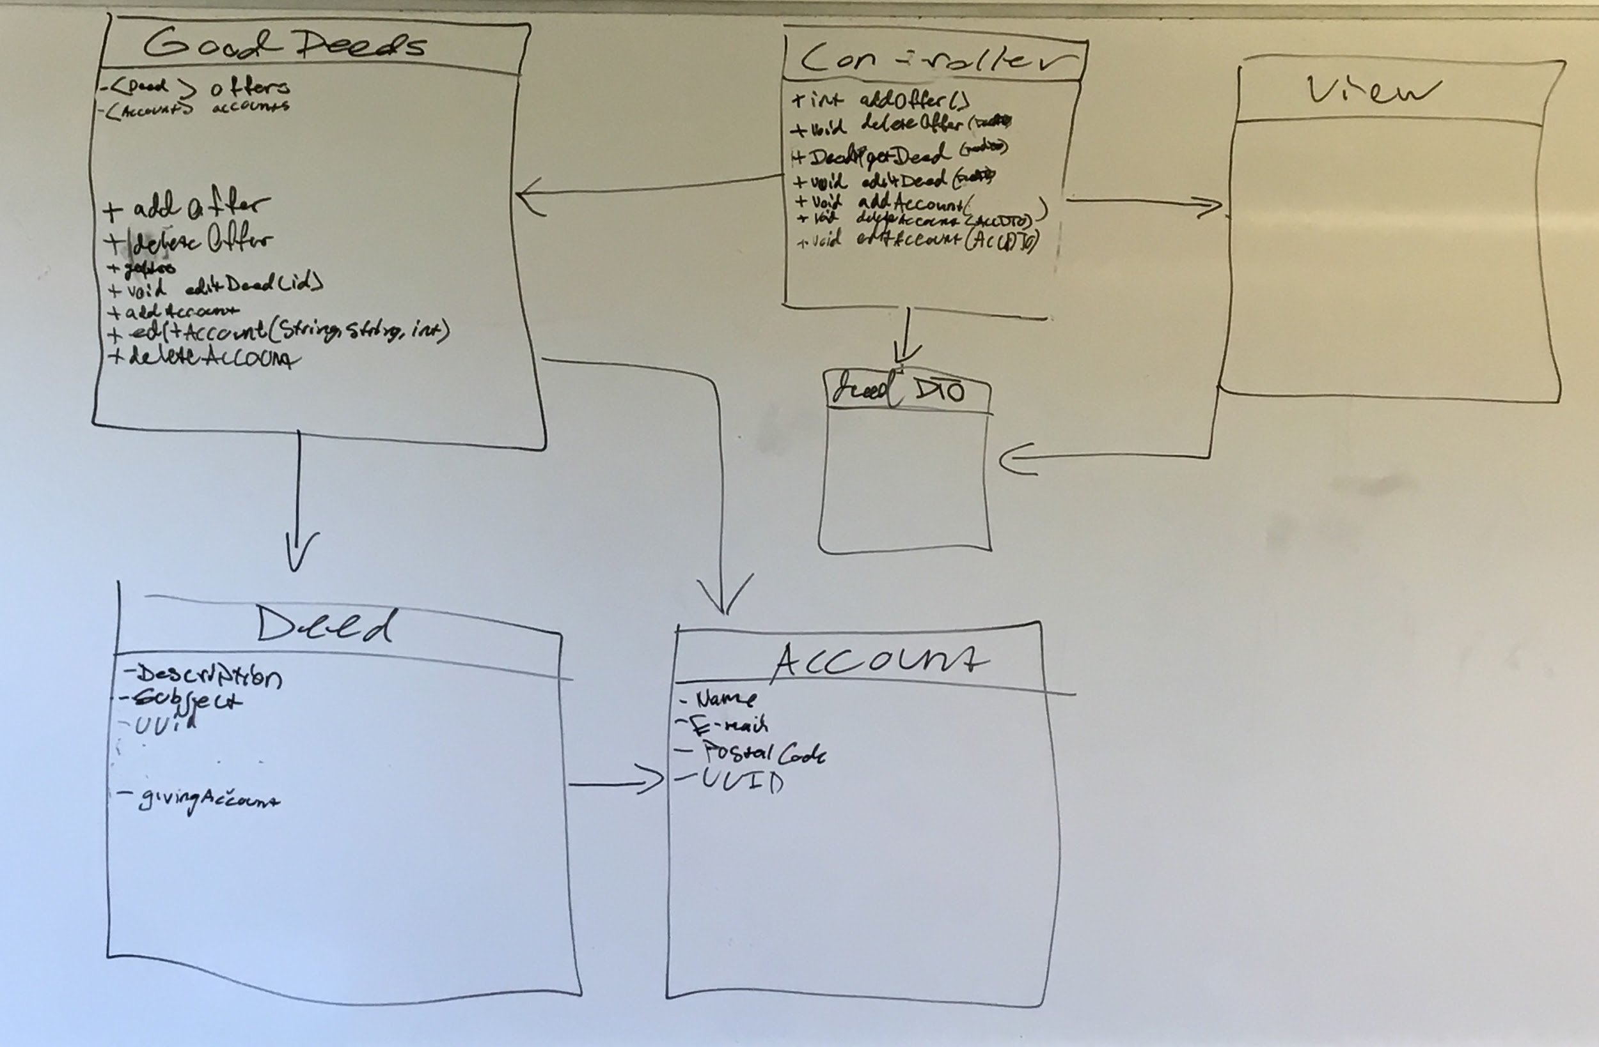

Anton drew a view-view on the board:

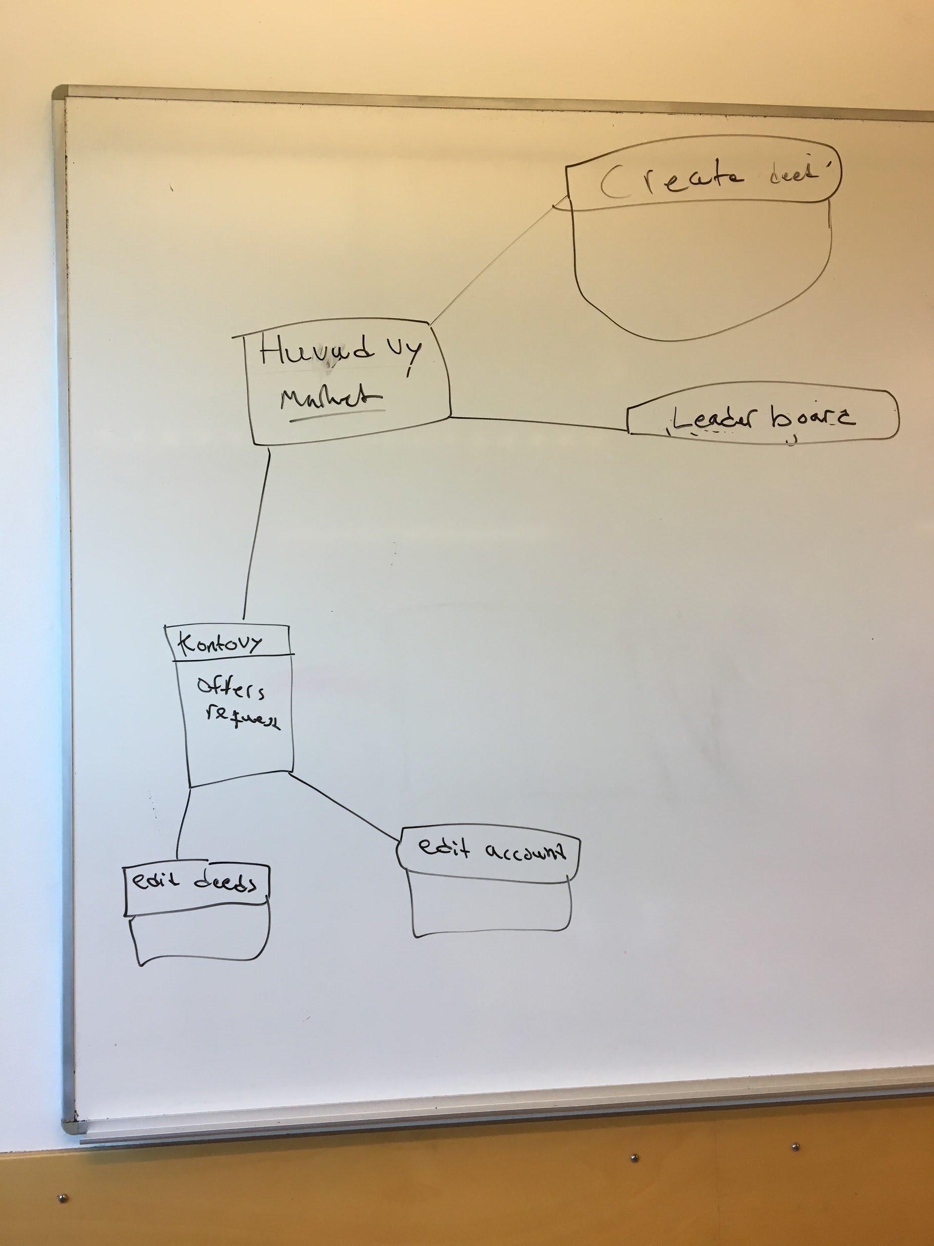

What should be the first thing you see when you open the app?  
Should we use a Burger menu? a Drop-down menu?

Should you be able to only ask for help? Negative karma? We discussed the psychological aspect of “karma”, helping others and voluntary work.

**Next meeting**

How should we implement MVC? Should view get objects from the modell? Ask Alex.

Is Travis Mandatory?

If all goes well, write the basic software architecture.